**Definition: Create the design using Alignment, Distribution, & Tidy up Properties.**

**Solution:**

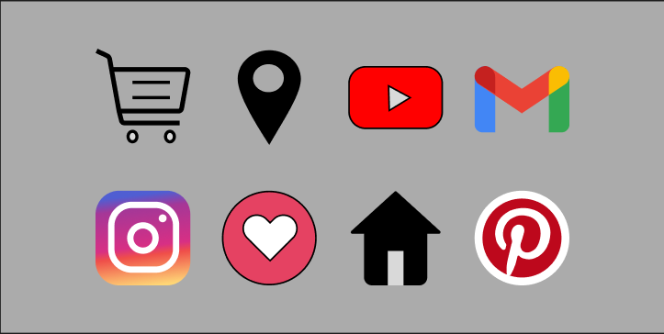

**Steps:**

* First Open Figma in browser mode.
* Then create the new document **File à New Figma Design.**
* Set the background page color=”**#1E1E1E**”.
* Take the frame of height=**”210 px”** and width=**”420 px”** and fill color=**”#ABABAB”.**
* **Steps for Cart:**
* Take the 2 ellipses for **wheel** height=”**8 px**” and width=”**8 px**” and fill color=”**#000000**”.
* Apply stroke **2 px on inside** and color=”**#000000**”.
* Take the 2 lines of height=”**0 px**” and width=”**23 px**”.
* Take the pen tool and draw **trolley of** height=”**60 px**” and width=”**60 px**”.
* **Steps for Location:**
* Take the ellipse-1 for height=”**60 px**” and width=”**40 px**” and fill color=”**#000000**”.
* Take the ellipse-2 for height=”**20 px**” and width=”**20 px**” and fill color=”**#000000**”.
* **Steps for YouTube:**
* Take the rectangle for height=”**40 px**”, width=”**60 px**”, corner radius=”**12**” and fill color=”**#FF0000**”.
* Apply stroke **2 px on inside** and color=”**#000000**”.
* Take the polygon for height=”**20 px**”, width=”**20 px**”, rotation=”**-88.5°”** and fill color=”**#FFFFFF**”.
* Apply stroke **1 px on inside** and color=”#**000000**”.
* **Steps for Gmail:**
* Take a rectangle of width=”**13 px**” and height=”**42 px**” give radius to top left corner, top right corner and bottom left corner “**5**” and fill color**=”#4286F5”.**
* Duplicate this rectangle and fill color**=”#34A853”.**
* Take another rectangle of width=”**60 px**” and height=” **30 px**”, bend using the move tool from the center of the rectangle, fill color “**#EA4235**” and place it in the middle of the two rectangles.
* **Steps for Instagram:**
* Take the rectangle-1 for height=”**60 px**” and width=”**60 px**” and fill linear gradient color=”**#505ED2**”, “**#A53797**”, “**#D72F84**”, “**#EF4E49**”, “**#FED676**”.
* Take the rectangle-2 for inside rectangle-1 height=”**45 px**” and width=”**45 px**”, corner radius=”**15**”, opacity=”**0**” and fill color=”**#D9D9D9**”.
* Apply stroke 4 **px on inside** and fill color**=”#FFFFFF”.**
* Take the ellipse-1 inside rectangle-2 height=”**20 px**” and width=”**20 px**”, opacity=”**0**” and fill color=”**#D9D9D9**”.
* Apply stroke **5 px on inside** and fill color**=”#FFFFFF”.**
* Take the ellipse-2 inside rectangle-2 of height=”**5 px**” and width=”**5 px**” and fill color=”**#D9D9D9**”.
* **Steps for Like Button:**
* Take the ellipse height=”**60 px**” and width=”**60 px**” and fill color=”**# E54262**”.
* Take rectangle-1 inside the ellipse edit for bend tool height=”35 **px**” and width=”35 **px**”, rotation=”**44.7°**” and fill color=”**#FFFFFF**”.
* Make a copy rectangle-2 to the opposite side.
* Apply stroke **1 px on inside** and color=”**#000000**”.
* **Steps for Home Icon:**
* Take the rectangle-1 for **wall** of height=”**30 px**” and width=”**40 px**” and fill color=”**#000000**”.
* Take the rectangle-2 inside of rectangle-1 for door rectangle-2 height=”**20 px**” and width=”**10 px**” and fill color=”**#D9D9D9**”.
* Take the polygon for ceiling of height=”**25 px**” and width=”**60 px**” and fill color=”**#000000**”.
* **Steps for Pinterest:**
* Take the ellipse height=”**60 px**” , width=”**60 px**” and fill color=”**#BD081C**”.
* Apply stroke **5 px on inside** and color=”**#FFFFFF**”.
* Take Pan tool and draw “**P**” of height=”**43 px**” and width=”**35 px**” and fill color=”**#FFFFFF**”.
* Now, Go to the **Export** button in the property panel. And **Export** it with .**JPG/.PNG** format.